Electromagnetism and Scanning Electron Microscopy
Chapel Hill Analytical and Nanofabrication Laboratory (CHANL) at UNC Chapel Hill
Brought to you by: Research Triangle Nanotechnology Network (RTNN)

CHANL invites you and your students to come take a deeper look into the nuts and bolts of electron microscopy!
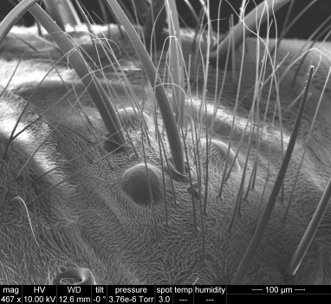
Summary: Electron microscopy allows scientists to image nanoscale features with a beam of electrons. Electromagnetic lenses are used to focus and shape the electron beam in order to produce well-resolved images. This experience is designed to show that physics concepts play an important role in instrumental design and operation.
Students will: discuss the differences between optical and electron microscopes, learn how electromagnetic lenses work, handle an electromagnetic lens and learn about its components, and use a scanning electron microscope (SEM) to image samples. Students will see how changing the current in an electromagnetic lens greatly alters the image produced.
Figure 1. SEM image of fly ocelli.
Target grades: College-level physics classes
Preparation:
- Review basic principles of light microscopy (suggested topics provided)
- Review how an electromagnetic lens works (diagram and notes provided)
- Schedule a visit to CHANL.
Format: Remote workshop or UNC campus visit (45 mins)
- Discussion about light and electron microscopes (10 mins)
  - Students will formulate similarities and differences between light and electron microscopy
- Demo: electromagnetic lens and discussion about how it works within the SEM (10 mins)
  - Students will see and handle an electromagnetic lens and learn how each component of the lens works.
- Demo: using an SEM for analysis (20-25 mins)
  - Students will get to choose from a variety of samples (for example: plants, insects, photo-patterned silicon) and see how adjustments to the SEM conditions can alter the image.
Going deeper: Students can make predictions about how each condition can be altered to change the image and then test their prediction on the SEM.
Note: If a visit to CHANL is not possible, we can Skype with your classroom.

