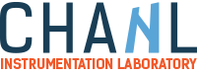
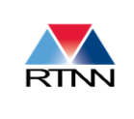
Hands on Nanoparticle Characterization Lab Experience
Chapel Hill Analytical and Nanofabrication Laboratory – UNC Chapel Hill
Brought to you by: Research Triangle Nanotechnology Network (RTNN)
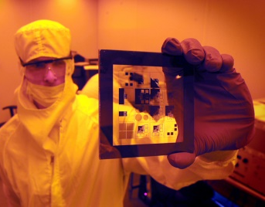
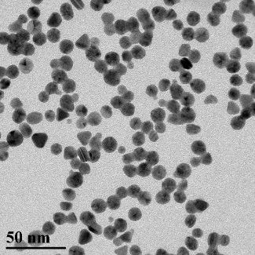
Summary: Nanoparticles are used in all kinds of things you interact with on a daily basis including sunscreens, antibiotic treatments, solar cells, and cosmetics. CHANL invites you and your students to synthesize gold nanoparticles in your lab classroom and characterize those nanoparticles with a variety of analytical instrumentation in CHANL. The students will confirm the synthesis of the nanoparticles using ultra-violet spectroscopy (UV-vis), acquire images of their nanoparticles using transmission electron microscopy (TEM), and quantify their chemical composition using energy-dispersive spectroscopy (EDS). Their visit to CHANL will also include a tour of our facility, including our cleanroom, to learn about other cutting-edge analytical instrumentation and nanofabrication equipment.
Scientist in cleanroom.
Target grades: 9-12, undergraduates
TEM of Au Nanoparticles
Preparation:
- Review principles of UV-vis, TEM, and EDS with students using provided power-point presentation.
- Purchase supplies for gold nanoparticle synthesis (lesson plan provided).
- Schedule a visit to CHANL.
Session 1: Preparation of gold nanoparticles (Classroom, ~1 hour)
- Synthesize gold nanoparticles using provided protocol.
- Collect samples in labeled and capped vials for analysis.
Session 2: Analysis of gold nanoparticles/tour of facilities (CHANL, ~2 hours for 10-15 students)
- Transmission electron microscopy (TEM): Students will see images of their samples and be able to measure the size of their nanoparticles.
- UV-vis spectroscopy: Students will prepare samples for UV-vis analysis and run their own samples on this instrument.
- Energy-dispersive spectroscopy (EDS): Students will see the instrument in action and determine the chemical composition of their nanoparticle samples.
- Tour: Students will be introduced to nanofabrication and how other materials can be created at the nano-scale.
Going deeper: Students can vary experimental conditions and analyze the data for trends—options are provided in the lesson plan.
Note: If a visit to CHANL cannot be made, we can Skype with your classroom to analyze their samples remotely.

